Name: _______________________ Class: __________ Date: _______
Instructions: Write answers in the right-hand column. Score: ___________ / 53 marks
Section A— Multiple choice (10 marks)

 | State the type of scientist who names and classifies things.  A Ecologist  B Biologist  C Taxonomist  D Zoologist | C | 1
 | Some plants are known as weeds. Describe a weed.  A A plant that does not grow very well  B A plant that grows where it is not wanted  C A plant that grows out of control  D A plant that does not produce flowers | b | 1
 | Identify the characteristic that would be suitable for use in a strong key to identify dogs.  A The loudness of their bark  B The presence of a patch of different coloured fur around their eye  C Whether they were short-haired or long-haired  D The size of their paws | c | 1
 | Identify which of the following statements about the levels of classification is true.  A There are more different types of organisms in a class compared to a genus.  B Phylum is a group within a family.  C There are many classes within an order.  D The organisms within a kingdom are most like each other. | A | 1
 | Select the best description of the term binomial nomenclature.  A A system or scientific naming that was used in the past but is no longer used.  B Using only two names to identify any living thing.  C A system of naming that does not change.  D A shorthand version of the name of an organism. | B | 1
 | Select the plants from this group that are most closely related:  Hakea sericea Grevillea sericea  Hakea pachyphylla Acacia pachyphylla  A Hakea sericea, Grevillea sericea  B Acacia pachyphylla, Hakea pachyphylla  C Hakea sericea, Hakea pachyphylla  D Grevillea sericea, Acacia pachyphylla | C | 1
 | From the statement below, deduce which pair of organisms are most alike.  A and B belong to the same Genus. A and C belong to the same Order.  C and B belong to the same Family. They all belong to the same Kingdom as D.  A A and B  B A and C  C C and B  D C and D | A | 1
 | Identify the phylum this animal belongs to.  It lives in water. It filters its food out of the water that passes through the pores in its body. Wastes and water are pushed out through a hole in the top of its body.  A Cnidarian  B Annelid  C Nematode  D Poriferan | D | 1
 | Identify the phylum this animal belongs to.  It lives in water or very moist places. It is bilaterally symmetrical with a body flattened from top to bottom. Many are scavengers in the ocean.  A Poriferan  B Nematode  C Echinoderm  D Platyhelminth | d | 1
 | Identify the class this plant belongs to.  It produces seeds. There are separate male and female plants. The male plant produces pollen in cones. The female also produces cones. These cones protect the developing seed.  A Cycad  B Ginkgo  C Conifer  D Flowering plant | a | 1

Section B— Short answer (30 marks)

- ` | Explain the following observation. Mushrooms grow well under the house, whereas grass growing there turns yellow and dies. | Mushrooms are a type of fungi. They are decomposers that feed on dead or decaying matter. They have no chlorophyll and do not perform photosynthesis. They do not need light to survive. Grass contains chlorophyll and needs light to make its food by photosynthesis. | 3
 | Using the dichotomous key provided, describe the characteristics of:  a a mosquito  b a grasshopper  c a termite soldier  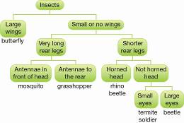 | a Insect with small or no wings, very long rear legs and antennae in front of the head.  b Insect with small or no wings, very long rear legs and antennae to the rear of the head.  c Insect with small or no wings, shorter rear legs, no horns on head and small eyes. | 5
 | Below is a list of vehicles. Construct a key that would allow someone who was unfamiliar with them to identify them.  bicycle, tricycle, helicopter, train, bus, tram, car, motorbike, sailboat, motorboat, jet ski | There are many alternative answers to this question, but the following characteristics are useful for placing them into groups: what they travel in or on (air, water, land); how they move; the number of wheels; the number of people they accommodate. The key need not be dichotomous. Give full marks if the key works. | 5
 | Use the classification key provided to help you classify the following organisms. For each invertebrate, write down the features listed as you progress through the key.  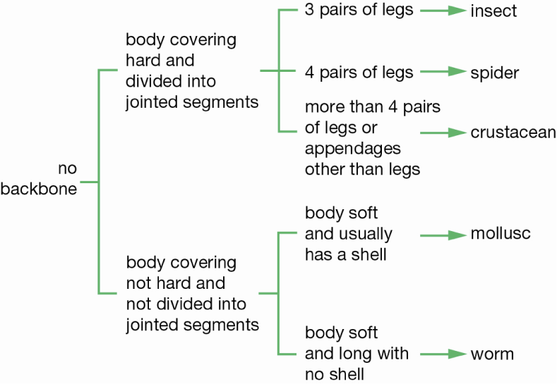  a Snail  b Garden worm  c Huntsman  d Butterfly | a Snail: no backbone, body covering not hard and not divided into jointed segments, body soft and usually has a shell → mollusc  b Garden worm: no backbone, body covering not hard and not divided into jointed segments, body soft and long with no shell → worm  c Huntsman: no backbone, body covering hard and divided into segments, four pairs of legs → spider  d Butterfly: no backbone, body covering hard and divided into segments, three pairs of legs → insect | 4
 | Read the four descriptions of chordates.  Animal 1: four legs, body covering of scales, ectothermic  Animal 2: body covering of hair, endothermic, some lay eggs  Animal 3: body covering of scales, fins, lives in water  Animal 4: body covering of feathers, endothermic, scales on legs  Propose the animal that belongs to each group.  Group  Animal number  Mammal  Bird  Reptile  Fish | Group  Animal number  Mammal  2  Bird  4  Reptile  1  Fish  3 | 4
 | Modify the following list to reflect the levels of classification from the largest to the smallest group.  class, family, genus, kingdom, order, phylum, species | kingdom, phylum, class, order, family, genus, species | 1
 | Match each term below with the correct definition.  a Monera  b Protist  c Fungi  d Plant  e Animal  i Microscopic single-celled organisms with a distinct nucleus.  ii Multicellular organisms with a distinct nucleus but without cell walls. Lack chlorophyll.  iii Microscopic single-celled organisms without a distinct nucleus.  iv Multicellular organisms with cell walls and a distinct nucleus. Lack chlorophyll.  v Multicellular organisms with cell walls and a distinct nucleus. Some cells contain chlorophyll. | a–iii  b–i  c–iv  d–v  e–ii | 1
 | a From the information below, select the animals that are most closely related.  Animal 1  Kingdom: Animal  Phylum: Chordate  Class: Mammal  Order: Carnivore  Family: Felidae  Genus: Panthera  Species: Panthera leo  Animal 2  Kingdom: Animal  Phylum: Chordate  Class: Mammal  Order: Diprotodontia  Family: Vombatidae  Genus: Vombatus  Species: Vombatus ursinus  Animal 3  Kingdom: Animal  Phylum: Chordate  Class: Sauropsida  Order: Testudines  Family: Testudinidae  Genus: Geochelone  Species: Geochelone gigantea  Animal 4  Kingdom: Animal  Phylum: Chordate  Class: Mammal  Order: Diprotodontia  Family: Macropodidae  Genus: Macropus  Species: Macropus giganteus  b Explain your decision. | a Animals 2 and 4  b The animals most closely related are the ones that belong to the same groups at the lowest level of classification. Animals 2 and 4 both belong to the same order. Animal 1 belongs to a different order from Animals 2 and 4. Animal 3 belongs to a different class from Animals1, 2 and 4. | 3
 | a Figures A, B and C are images of cells. Identify the kingdom to which the organisms with these cells belong.  A 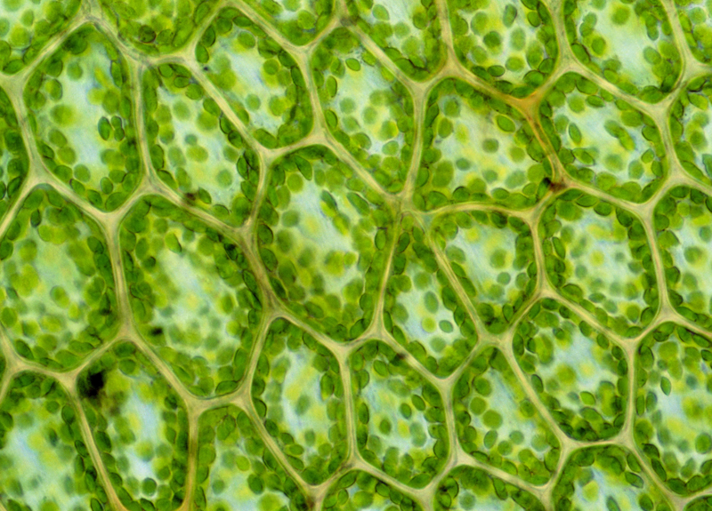  B 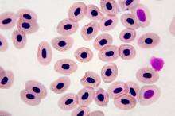  C 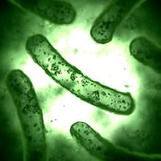  b Justify your response. | a A–Plant  B–Animal  C Monera  b The cell in A are part of a multi-cellular organism, have a cell wall and chloroplasts. This is typical of plants.  The cells in B are part of a multi-cellular organism, have a cell membrane to the outside and there is a distinct nucleus. This is typical of animals.  C is a single-celled organism with a cell wall and no distinct nucleus. This is typical of monera. | 3
 | a Name the three groups of mammals.  b Describe the differences that cause mammals to be separated into these three groups. | a Placentals, marsupials, monotremes  B Monotremes are different from other mammals in that they lay eggs. Marsupials give birth to very immature young that are suckled in a pouch. Placentals nourish their young within the body of the mother by a placenta. The baby is born at a more mature stage. | 1

Section C— Thinking scientifically (10 marks)

 | Students created this key for their group.  1a  Male  Go to 2  b  Female  Go to 5  2a  Straight hair  Go to 3  b  Curly hair  Go to 4  3a  Can roll tongue  Mark  b  Cannot roll tongue  Yasu  4a  Brown eyes  Hans  b  Grey eyes  Jack  5a  Straight hair  Jane  b  Curly hair  Mai  Identify the description of Jack.  A Straight-haired male with brown eyes that cannot role his tongue.  B Curly-haired male with grey eyes.  C Male that can roll his tongue and has grey eyes and curly hair.  D Male with straight hair and brown eyes. | B | 1
 | Use the circular key below to classify an animal with 6 legs, 4 heads, 8 eyes and no mouth.  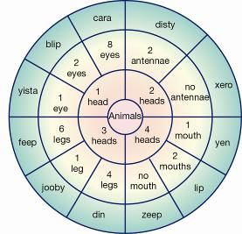  A Feep  B Xero  C Cara  D Zeep | D | 1
 | Use the circular key below to classify an animal that has four legs and one head with two eyes and no antennae.  A Din  B Xero  C Blip  D Yista | C | 1
 | Use the following key to identify the leaf shown below.  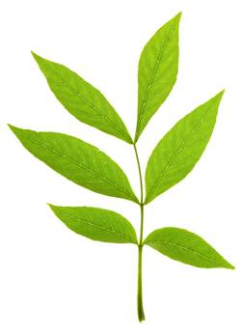  1a Leaf blade divided into many parts (leaflets) 4  b Leaf blade entire (not divided) 2  2a Leaf shaped like a hand with fingers spread Maple  b Leaf not hand-shaped 3  3a Leaf margin (edge) has small teeth Rose  b Leaf margin is lobed Oak  4a Leaflets organised like fingers on a hand Chestnut  b Leaflets on either side of main vein Ash  A Chestnut  B Rose  C Ash  D Maple | C | 1
 | Use the following key to identify the correct description of an oak leaf.  1a Leaf blade divided into many parts (leaflets) 4  b Leaf blade entire (not divided) 2  2a Leaf shaped like a hand with fingers spread Maple  b Leaf not hand-shaped 3  3a Leaf margin (edge) has small teeth Rose  b Leaf margin is lobed Oak  4a Leaflets organised like fingers on a hand Chestnut  b Leaflets on either side of main vein Ash  A Leaf divided into many leaflets with lobed edges.  B Leaf with an entire blade that is lobed at the edges. Not shaped like a hand.  C Leaf with an entire blade with the veins looking like the five fingers of a hand.  D Leaf divided into leaflets organised like a hand. | B | 1
 | Use the key in question 4 to identify leaves A and B.  1a Leaf blade divided into many parts (leaflets) 4  b Leaf blade entire (not divided) 2  2a Leaf shaped like a hand with fingers spread Maple  b Leaf not hand-shaped 3  3a Leaf margin (edge) has small teeth Rose  b Leaf margin is lobed Oak  4a Leaflets organised like fingers on a hand Chestnut  b Leaflets on either side of main vein Ash  Leaf A 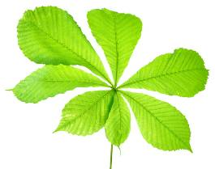  Leaf B 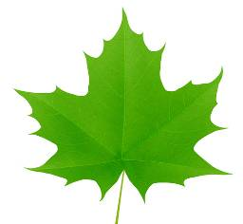  A A–Rose, B–Maple  B A–Chestnut, B–Maple  C A–Oak, B–Chestnut  D A–Maple, B–Rose | B | 1
 | Propose the phylum to which the organism in the picture belongs.  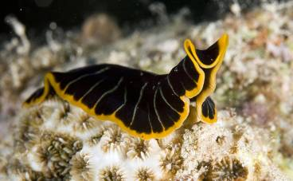  A Platyhelminth  B Nematode  C Annelid  D Mollusc | A | 1
 | Both these animals belong to the Arthropod phylum. Propose the characteristic that is not typical of all members of this phylum.  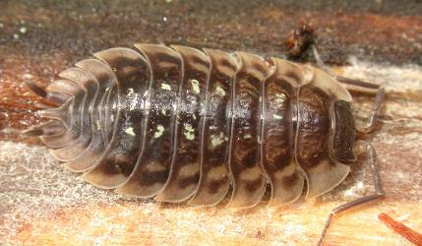  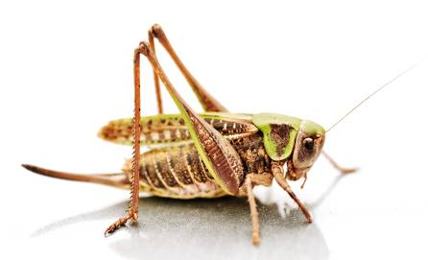  A The presence of jointed legs  B Having segmented bodies  C Having an exoskeleton  D Having a pair of long antennae | D | 1
 | An animal with an exoskeleton must moult before it can grow. This means that the animal gets rid of its old, small exoskeleton and forms a new and larger one. Moulting happens when the casing or shell cracks open and drops off. A new, larger exoskeleton then forms. It starts soft but then hardens to form a new shell or casing for the animal.  Empty and dried shell-like casings of cicadas are often found on trees. Identify which of the following best describes these casings:  A The casings are the old exoskeletons of cicadas that were moulted when the cicadas grew.  B The cicadas are growing within these casings but are currently too small to see.  C The casings are the eggs of new cicadas.  D The casings are the remains of dead cicadas. | A | 1
 | Chordates have a skeleton inside their bodies. This type of skeleton is known as an endoskeleton. An exoskeleton is very different. An exoskeleton is a hard, external skeleton that forms a shell or casing around the animal, its body, head, tail and legs. Arthropods have an exoskeleton.  Identify which of the following is the best meaning for the prefixes endo and exo when discussing skeletons:  A endo and exo both mean the same thing.  B endo means external, exo means internal.  C endo means internal, exo means external.  D endo means that an animal has a skeleton, exo means that an animal has none. | C | 1

